Weeks 1 and 2 Club Notes (Right-handed)
- We learnt these chords:
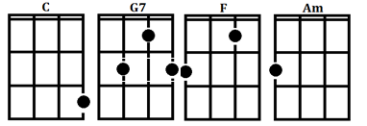
- We learnt notation for chords:
0003 is C 0212 is G7 2010 is F 2000 is Am
- We found a good ukulele tuner online at www.ukutuner.com
- We learnt that the ukulele was tuned like this: G C E A
- We learnt these songs:
Stand By Me

Weeks 1 and 2 Club Notes (Left-handed)
- We learnt these chords:
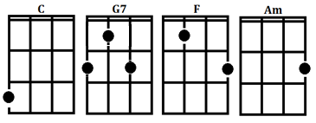
- We learnt notation for chords:
0003 is C 0212 is G7 2010 is F 2000 is Am
- We found a good ukulele tuner online at www.ukutuner.com
- We learnt that the ukulele was tuned like this: A E C G
- We learnt these songs:
Stand By Me

Weeks 3 and 4 Club Notes (Right-Handed)

We learnt some strumming patterns this time. Try some of these:

- d d u u d
- d d u u d u
- d d d u d u
- d d u d u d u
Then we practised the C (0003) G (0232) Am (2000) F (2010) chord pattern and used it to learn the song “You’re Beautiful” by James Blunt:

C
My life is brilliant
G
My love is pure
Am
I saw an angel
F
Of that I'm sure
C
She smiled at me on the subway
G
She was with another man
Am
But I won't lose no sleep on that
F
'Cause I've got a plan

Chorus:
F G
You're beautiful
C
You're beautiful
F G C
You're beautiful, it's true
F G
I saw your face
C Am
In a crowded place
F G Am
And I don't know what to do
F G C
'Cause I'll never be with you

Challenge: Write your own four chord song using these chords!

Weeks 3 and 4 Club Notes (Left-Handed)

We learnt some strumming patterns this time. Try some of these:

- d d u u d
- d d u u d u
- d d d u d u
- d d u d u d u
Then we practised the C (3000) G (2320) Am (0002) F (0102) chord pattern and used it to learn the song “You’re Beautiful” by James Blunt:

C
My life is brilliant
G
My love is pure
Am
I saw an angel
F
Of that I'm sure
C
She smiled at me on the subway
G
She was with another man
Am
But I won't lose no sleep on that
F
'Cause I've got a plan

Chorus:
F G
You're beautiful
C
You're beautiful
F G C
You're beautiful, it's true
F G
I saw your face
C Am
In a crowded place
F G Am
And I don't know what to do
F G C
'Cause I'll never be with you

Challenge: Write your own four chord song using these chords!

