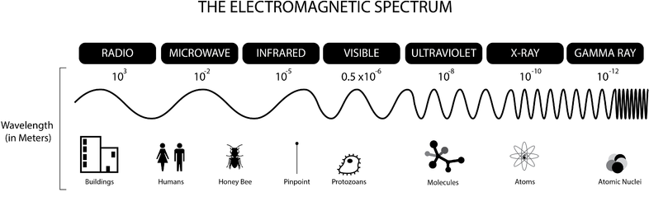
Common features of all EM waves:
Other information:
Radio | Microwaves | I-R | Visible | U-V | X-Rays | γ-Rays
Sources:  Detectors: | Sources:  Detectors: | Sources:  Detectors: | Sources:  Detectors: | Sources:  Detectors: | Sources:  Detectors: | Sources:  Detectors:
Uses: | Uses: | Uses: | Uses: | Uses: | Uses: | Uses:

