DigiLittle Acorns Personal Learning Network
Final Project Report

By
Christine Turner
English Martyrs’ School, Leicester

July 2014

CHAPTER ONE INTRODUCTION

  - Introduction

In Summer 2013, Leicester City Council announced potential funding for schools wishing to undertake professional development in improving digital literacy. It is widely agreed in the literature that children are ‘digital natives’ (Prensky, 2001). However, there exists a potential divide between the digital literacy of staff and students in a school. In 2011, Ofcom suggested that:

“…half (50%) of all children aged 5-15 have a mobile phone, and close to one in five (18%) parents of children aged 5-15 say their child has a smartphone. As with overall incidence of mobile phone ownership, the likelihood of owning a mobile phone increases with the age of the child, with just 3% of 5-7s owning a smartphone, around one in eight 8-11s (13%) and around one in three 12-15s (35%).” (p.14)

The proportion of students having access to a tablet or smartphone seems to have rapidly increased since 2011. A quick survey of one tutor group at a secondary school in Leicester, for example suggested that all students had access, even if they did not own the device. Furthermore, students appear to enjoy using such technology. Apple’s iPad and iPhone seem popular choices amongst the 11-18 age group. If children are now digital technology ‘natives’ and enjoy using ICT at home, there exists a good possibility of engaging a class and influencing their learning using new ICT tools, for example iPads. With this in mind, the school applied for funding with which to buy a class set of iPad minis and learn how to make apps, and was successful in their bid. This report details the journey the school and project leads undertook during the 2013-2014 academic year.

  - The School

This project was conducted with the support of colleagues at English Martyrs’ School, Leicester. According to Ofsted (2014), the school has around 1050 students on roll and draws its students from across the city and beyond its boundary. Students come from a wide range of different backgrounds. Most are White British, although almost one fifth are from other ethnic backgrounds, a higher proportion than is found nationally. The proportion of pupils entitled to Free School Meals (FSM) is below average and the proportion with learning difficulties or disabilities is in line with the national figure. The proportion of students with English as an Additional Language (EAL) is higher than found nationally.

Although going through a major rebuild, due to BSF, the school’s current computing facilities are as follows: 6 classrooms with between 20 and 30 computers in each, and a Library with 18 computers (and 8 laptops for sixth form use only). All rooms are able to be booked by staff for use with their classes, although this is dependent upon availability, as the rooms may be booked up to two weeks in advance, via an online booking facility. Students are able to book computers in the Library during break and lunch time and they are also able to use the library after school in homework club. The sixth form‘s small computer (laptop) room in the Library is for their sole use. Staff in the science department felt that they lacked reliable ICT facilities and a class set of iPads would be of great benefit.

  - The Project Leads

Christine Turner is a Chemistry Teacher at English Martyrs' School. Rated as a Pioneer in 5 of the 6 DigiLit Framework strands, she wanted to share her knowledge with her colleagues in the school, and if possible, in the city. She was invited to be on the Schools Expert Advisory Panel for the initial DigiLit framework. For the last 3 years, Christine had been completing her MPhil in ICT in Teaching and Learning with Loughborough University, and has penned a thesis entitled "Learner Generated Content Using Web 2.0 Technologies - Does the use of webtools and web technologies in the classroom have a positive impact on students' perceptions of their learning?" Christine had already developed a series of websites and wikis which she has used with her students. These can be viewed on her website (http://www.christineturner.co.uk). Christine hoped that by the end of the project, a class set of iPads would have been purchased and used effectively to support teaching and learning, by several colleagues.

Ian Sadler is a Chemistry Teacher at English Martyrs' School. Ian's current interest is the development of 'Apps' for use in the Science classroom. Ian's wanted teachers in the Science Department are to learn how to create free apps, e.g. revision quizzes using www.appshed.com, share them with students and evaluate them. This required Ian to firstly learn how to create apps himself (something he has never done before) then teach his colleagues how to create apps. Ian hoped that by the summer term, a Chemist, Biologist and a Physicist in the department will have successfully made a relevant app that has been trialled by students and found to have improved their learning.

Stephanie Patrick is a Biology Teacher at English Martyrs' School. Having recently bought herself an iPad, Stephanie started to think about how she could use it to help her teaching and her students' learning. Stephanie wanted to research what apps already exist for educators, trial some in her lessons, then teach others how to use them. She thought that her students would find using iPads in lessons engaging, as many already own similar technologies. However, as few of her colleagues in the Science Department own iPads, she would need to demonstrate to them how and why the iPad's features have supported teaching and learning. Stephanie hoped that by the summer term she will have evaluated three different types of app (or other feature) and supported her 'Core' colleagues in trying them out too. Christine, Ian and Stephanie were supported by the rest of the Science Department during the project.

  - Issues

The broad issues associated with undertaking this project were as follows:

    - Access

Would all concern agree that the iPads could be purchased and supported? If for any reason the iPads could not be purchased, the project would rely solely on students using their own devices. As students are forbidden to bring their own devices to school, this would rely on them using the apps at home, which may produce unreliable results. Permission, therefore, from the school’s Principal, was sought and gained. It was also wondered if the Wi-Fi signal would be good enough for students to connect to the Internet. If not, offline apps must be sought and built.

    - Skills

Would the project leads have the necessary skills to deliver the project? There is some evidence in the literature that although adults may be confident with the use hardware like televisions, which they have grown up with, they may be fearful of allowing children to have access to the Internet. Byron’s report, she comments that:

“In the course of my Review many of the people I have spoken to characterize this as many adults being of the Web 1.0 generation (using the internet to search for information or for shopping) while our children are the Web 2.0 generation, using the technology in increasingly sophisticated ways to create and upload their own material.” (Byron, 2008, p.23)

It was thought that the teachers involved in this research may have similar concerns with using the iPads due to this digital divide, where they fear that the students are more adept at using them than the teachers. Time and resources with which to conduct effective CPD must be therefore be budgeted for.

    - Expertise in the field

Would the project leads be able to find enough expertise in the field? If the Appshed tutorials were not clear, then someone who had used Appshed before may have needed to be consulted. ICT support would also be needed. This was kindly provided by the school’s ICT team. Fortunately, watching the tutorials was all that was required to be able to make a basic app.

    - Time and availability

Would the project leads be able to purchase the iPads in enough time to complete meaningful research? It was thought that if this was not completed promptly, there may not be enough time to deliver the project. Would the project leads and other teachers have enough time outside of their regular duties to complete the project? If any member of staff was absent this may have affected the outcome. The school was also due an Ofsted inspection so this may have affected the amount of time available. This indeed was a major issue. The project leads found that having enough time to complete the project was a barrier, and thus the project ran a fortnight behind schedule.

1.4.5 Funding

What would happen if the funding for the project did not come through? It was thought that many of the activities could be completed without funding, but the iPads could not be purchased without support from the DigiLit project. Fortunately, funding was acquired and only took a short time for the iPads to be purchased once they had been ordered.

    - Change to practice

Would the members of the department embrace changes to their current practice? It was thought that some members of the department would be keen to use new technology, whilst others may not even want to use their iPad at home, let alone in the classroom. Support from the former group for the latter was therefore essential.

    - Scope of the research

Was the scope of the project too broad? Having three strands may have proved too large a project for the projected timescale. Alternatively, the teachers may have wanted to focus on one particular strand, which would have made this a more restricted study in terms of its breadth. It was certainly found that developing a PLN as well as overseeing the project was extremely challenging.

1.5 Research questions and hypothesis

The research questions were as follows:

- When considering the use of iPads in lessons, do students find them a) easy to use b) fun to use and c) able to be used as a tool for learning?
- When considering the use of Appshed to build apps, do developers find it easy to use and do users find the apps made a) easy to use b) fun to use and c) able to be used as a tool for learning?
- When considering the development of a Personal Learning Network, which tools support this and what are the benefits?

It was hypothesised that the students would enjoy using the iPads in lessons if appropriate apps could be found or built and the necessary infrastructure was reliable. On initial use, it appeared that Appshed would be effective in producing some simple apps that students would find beneficial. It was thought that the use of a website, Facebook and Twitter, alongside any networking opportunities and iPad courses attended would support the effective development of a Personal Learning Network (PLN). The benefits may be personal or school/city wide.

1.6 Goals

As a result of this research, the researcher hoped to demonstrate the benefits of using apps and iPads in teaching and learning in the Science classroom. It was hoped that access to appropriate, co-operative teaching groups and colleagues would allow for sufficient data to be collected to be able, with caution, to suggest whether apps and iPads can improve students’ perceptions of their learning, at least in this school and effectively develop the digital literacy of department members.

CHAPTER TWO RESEARCH DESIGN

2.1 Design Frame

The design frame provides the framework for the research. Thomas (2009) states that the seven most common structures used in small scale research are case studies, comparative research, action research, ethnography, evaluation, experiment, and longitudinal or cross-sectional study or survey. The table below details the purposes of five of these design frames:
Model Purposes
Survey | Gathering large scale data  Making generalisations  Gathering data able to be statistically manipulated  Gathering context-free data
Experiment | Comparing under controlled conditions  Generalising about efficacy  Objective measurement Establishing causality
Ethnography | Portrayal of events in subjects’ terms  Subjective and reporting of multiple perspectives  Description, understanding and explanation of a specific situation
Action research | Plan, implement, review and evaluate an intervention designed to improve practice or solve a local problem  To empower participants through research involvement and ideology critique  To develop reflective practice and promote equality democracy  To link practice and research and promote collaborative research
Case study | To portray, analyse and interpret the uniqueness of real individuals and situations through accessible accounts  To catch the complexity behaviour  To contribute to action and intervention  To present and represent reality

Experiment was not a possible design frame due to the subjective nature of the research and survey could not be used because data were not able to be gathered on a large scale and was unlikely to be context-free. A possible design frame for this educational research was ‘Action Research’. The action research cycle (below) involves the experimenter continually planning and taking actions then critically reflecting on the outcomes of those actions. If this project is continued next year then it may be thought of as Action Research.

A specific example of action research is “practitioner research” (Fox et al., 2007, p.81) which is carried out by practitioners for the purpose of reflecting on and ultimately advancing their own practice. Although this project could be thought of as a series of case studies, the actual design frame involved in this research took the form of this action (practitioner) research. This allowed for many apps and the iPads themselves to be evaluated, whilst giving the teachers options on how to proceed further, in order to improve teaching and learning in the school. The research follows broadly an interpretivist or constructivist paradigm which may be thought of as the converse of positivist paradigm and:

“…proposes that the learner actively participates in the learning process…It assumes the fact that the individual learner takes active responsibility of the content of the material being learnt, the learning process, as well as the manner of instruction.” (Enonbun, 2010, p.21)

Even though questionnaires were given out during the research, the subjective nature of the project fits an interpretivist paradigm better.

2.2 eSafety and safeguarding of iPads

It was essential when planning that the school’s eSafety policy was considered. All Internet activity on the school’s network is logged by the school’s Internet Service Provider (ISP) and these logs may be monitored. A breach or suspected breach of policy by a School employee, contractor or student may result in the withdrawal of School ICT hardware, software or services as any policy breach is grounds for disciplinary action in accordance with the school’s disciplinary procedure. The members of staff and students involved in this project all signed an acceptable use agreement on joining the school, which included the following relevant statements:

- Staff will preview any recommended sites before use
- All users must observe copyright of materials from electronic resources
- Staff should not reveal names of colleagues, customers or clients or any other confidential information acquired through the job on any social networking site or blog
- It is at the Principal’s discretion on what Internet activities are permissible for staff and students in line with the school’s character and educational mission.
- At present, the school endeavours to deny access to social networking sites to students within school
- All students are advised to be cautious about the information given by others on sites, for example users not being who they say they are
- Students are always reminded to avoid giving out personal details on such sites which may identify them or where they are
- Students are encouraged to be wary about publishing specific and detailed private thoughts online
- Staff may only create blogs, wikis or other web 2 spaces in order to communicate with students using the VLE or other systems approved by the Principal

The issue with using iPads is that students are not able to log in to their user areas, so an alternative method of monitoring must be found. It was thought that if a log was kept as to which student had used each particular iPad on each lesson, then any inappropriate use could be monitored. The following Excel spreadsheet was therefore designed to keep track of bookings and users:

The spreadsheet allowed teachers to import class lists from SIMS. Columns could be added so that bookings were in time order. The students would also require rules on iPad use in the classroom. A set of rules was devised:
- Students are assigned a numbered iPad and are responsible for it until it is safely back in the cabinet.
- Students are not to wander round or swap iPads with others.
- The class is not dismissed until all the iPads are accounted for.
- It is suggested that the teacher leaves 10-15 minutes at the end of the lesson to ensure this.
- Lab rules apply to iPad lessons.
- If a student leaves the room they must give the iPad back to the teacher for safekeeping.
- Students are to only use the iPad for the purposes dictated by the teacher, e.g. no selfies.
- If an iPad goes missing, the class remains and a member of SLT is called.
- The iPads must be plugged in, by the teacher, to charge at the end of the lesson.

2.2 Data Collection

Many different methods of collecting data were discussed by the department. The table below compares and summarises some possible methods and data collection instruments (based on Thomas (2009) and Cohen et al. (2011)) that could have been used:

Method | Advantages | Disadvantages
Survey /  Questionnaire | Good for gathering descriptive data  Can cover a wide range of topics  Relatively inexpensive  Can be analysed with software  Time efficient  Can be anonymous  Possibility of high return rate | Data may lack depth  May not provide adequate data on the context
Observation  (structured, unstructured or participant) | Provides direct data about the behaviour of individuals and groups  Allows evaluator to enter into the situation  Exists in natural, unstructured, flexible settings | Expensive  Time consuming  May affect the behaviour of the participants  Observer may not be objective  Observed behaviours may be atypical
Interview  (structured, semi-structure, unstructured, group or individual) | Allows for face to face contact with respondents  Provides opportunity to explore topics in depth  Allows interviewer to explain or clarify questions  Increased likelihood of useful responses  Quickly and easily administered  Can be coded | Interviewer may influence responses  Interviewee may distort data through recall error  Interviewee may have selective perceptions  Interviewee may have the desire to please interviewer  Clarifications can result in inconsistencies  Volume of information very large so may be difficult to record and reduce
Test | Provides objective information  Can be made to match a given skill set  Can be easily stored | May be oversimplified or superficial  May be too complex  May not test knowledge adequately  May be time consuming  May be biased or subject to cheating or coaching
Documents  e.g. journals, diaries, accounts | Available locally  Grounded in the setting and language which they occur  Inexpensive and unobtrusive  On-going comparison with previous work | May be incomplete or inaccurate  Questionable authenticity  Locating documents may be difficult  Analysis may be time consuming  Access may be difficult
It was decided that observations would produce appropriate qualitative data and questionnaires would give quantitative data if required, which could be triangulated in order to give more reliable information. The forum on the website, Facebook and Twitter feeds would provide additional evidence.

2.2.1 Questionnaire design

The following worksheet was designed by Ian and Christine in order to focus students on the scientific learning points when using the Infection app:

Infection – the App Name:
Spend 20 minutes on the app – use the fast forward button to speed up time. Your learning aim is to be able to describe how microbes spread to cause a pandemic. Answer these questions after 20 minutes.

Transmission: How can microbes be spread?

What is a vector? Which vectors are used on the app?

Symptoms: Which symptoms of a disease allow a microbe to spread? Why?

Resistances: What can happen to microbes that make it difficult to find a cure?

How did countries try to stop the disease from spreading?

What else did the countries do to try to save people?

It was thought that by filling in this worksheet, students would be able to demonstrate whether the app had helped them to learn. After trialling with one group, it was thought that more probing and challenging questions could be added.
The worksheet was therefore edited to include these new questions. Lines were given in order to encourage the students to write neatly and take the task seriously, and the font was changed to Comic Sans in line with school policy:

Infection – the App Name:_______________

How can microbes be spread?
…………………………………………………………………………………………………………………………………………………
What is a vector? …………………………………………………………………………….…………………………………………………………………………………………………………………………………………………………………………………………………………………………………………………..…………………
What vectors are used on the app? ……………………………………………………………………………………………………………………………………………………………………………………………………………………………………………………………………………………………………………………………………………………
What other methods of transmission were there? ………………………………………………………………………………………………………………………………………………………………………………………………………………………………………………………………………………………………………………………………………..…………
What symptoms of a disease allow a microbe to be spread? Why?
………………………………………………………………………………………………………………………………………………………………………………………………………………………………………………………………………………..…………………………………………………………………
What can happen to microbes to make it difficult to find a cure?
……………………………………………………………………………………………………………………………………………………………………………………………………………………………………………………………………………………………………………………………………………………
What did the countries governments do to try and stop the spread of disease? …………………………………………………………………………………………………………………………………………………………………………………………………………………………………………………………………………………..………………………………………………………………
What did the countries governments do to try and cure the disease? ……………………………………………………………………………………………………………………………………………………………………………………………………………………………………………………………………………………………………………………………………………………
Which traits made the disease more noticeable? Which were more infectious? Which were more deadly? ………………………………………………………………………………………………………………………………………………………………………………………………………………………………………………………………………………..………………………….………………………………………
How successful were you on the App? Include data if you remember. How did you achieve this? Did you learn anything else? ………………………………………………………………………………………………………………………………………………………………………………………………………………………………………………………………………………………………………………………………………………………………………………………………………………………………………………………………………………………………………………………………

The following data collection form was designed by Christine in order to gauge students’ opinion on their experiences of using the iPads and apps in lessons:

iPads Evaluation

Not at all | Very little | Yes, quite a bit | Yes, a lot
- Did you enjoy using the iPads?

Comments:

Not at all | Very little | Yes, quite a bit | Yes, a lot
- Did you learn much from the iPad activity?

Comments:

Much less | A bit less | A bit more | Much more
- Do you think you learned more than in a ‘normal’ lesson?

Comments:

Very difficult | Quite difficult | Quite easy | Very easy

- How easy was the app to use?

Comments:

What scientific information did you learn from the app?

When designing the questionnaires, advice and guidance from the literature was sought and comparisons of other studies were made. Also, the advice given by Cohen et al. (2011, pp.386–390) on the advantages and disadvantages of using Likert scales was considered. It was thought that a four point Likert scale would be appropriate in order to encourage students to make a choice and not ‘opt out’ as can happen when including a ‘Neutral’ option on a five point scale. Again this questionnaire was trialled with the same group of students and then edited slightly in order to make inputting the data into Excel easier:

iPads Evaluation
Question |  | Not at all | Very little | Quite a bit | A lot | Comments
1 | Did you enjoy using the iPads? | 1 | 2 | 3 | 4
 |  | Not at all | Very little | Quite a bit | A lot | Comments
2 | Did you learn much from the iPad activity? | 1 | 2 | 3 | 4
 |  | Much less | A bit less | A bit more | Much more | Comments
3 | Do you think you learned more than in a ‘normal’ lesson? | 1 | 2 | 3 | 4
 |  | Very difficult | Quite difficult | Quite Easy | Very easy | Comments
4 | How easy to use was the app? | 1 | 2 | 3 | 4

What scientific information did you learn from using the app?
The questionnaire below was designed by Ian in order to collect data about his Bonding app:
Student Questionnaire

- What device did you use for this homework e.g. Nokia 3210?

______________________________________________________________________________________

- What difficulties did you come across when attempting this homework?
(tick as many boxes as apply)

I had no problems making the app work
I could not load the app
I could not save the app as an icon on the homescreen
The app did not work on my device
The external websites did not work properly
I had another problem not listed
Please describe the problem here
______________________________________________________________________________________________________________________________________________________________________________

- Did you find the bonding app homework useful? (Tick one box)

Not at all Very Little Yes quite a bit Yes a lot

- Would you like more homework set in this way? (Circle the answer)

Yes No Don’t Mind

- Do you have any suggestions for other topics in Science that a similar app could be produced for?
_______________________________________________________________________________________

Any Other Comments: ______________________________________________________________________

_________________________________________________________________________________________

Christine also trialled collecting data using an online data collection form. She used Polldaddy.com and the survey can be found at http://cturnerems.polldaddy.com/s/student-app-questionnaire. It is also below:
Top of Form
Q.1
Please type your name here: This is optional.
First Name Last Name
Q.2
What is your year group? *
12
13
Other:
Q.3
What device(s) did you use for this app activity? *
Blackberry
Samsung Galaxy
iPhone
iPad
Other tablet (please specify)
Other smartphone (please specify)
Other device (please specify)

Q.4
What difficulties did you come across when using this app? *
I had no problems making the app work
I could not load the app
I could not save the app as an icon on the home-screen
The app did not work on my device
The external websites did not work properly
I had another problem not listed

Q.5
Please select how much you agree with these statements *

 | Strongly disagree | Slightly disagree | Neutral/Undecided | Slightly agree | Strongly agree
I found the app useful
I would like more work set in this way
The app helped me to learn
The app could help others to learn
Using the app may improve my grade
Q.6
Do you have any suggestions for other topics in Science for which a similar app could be produced? *
Yes (please complete the box below)
No

Q.7
Do you have any other comments? *
Yes (please complete the box below)
No
Bottom of Form

CHAPTER THREE METHOD

3.1 Methods

3.1.1 App building

App development was the first activity undertaken, as it took time to order and receive the iPads and Appshed could be used on a PC. Both Ian and Christine made and trialled (on a small, pilot scale) apps that they had made using Appshed. Learning how to use Appshed was fairly straightforward using the videos linked to the Appshed website. Christine found Appshed quite easy to use, if a little cumbersome, but managed to make a Year 12 Chemistry app within a few hours. The next stage was to upload the app and test it, and look for mistakes. It is worth noting that developers can still edit their apps and users will be able to update their apps when they are connected to the internet.
Here is the web app: http://apps.appshed.com/155224/
Below is the QR code:
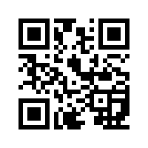
Christine posted the QR code to her app on her AS/A2 Chemistry website (www.emschemistry.yolasite.com) and asked her Year 12 class to try it out and complete an online evaluation, the results of which are in the next chapter.

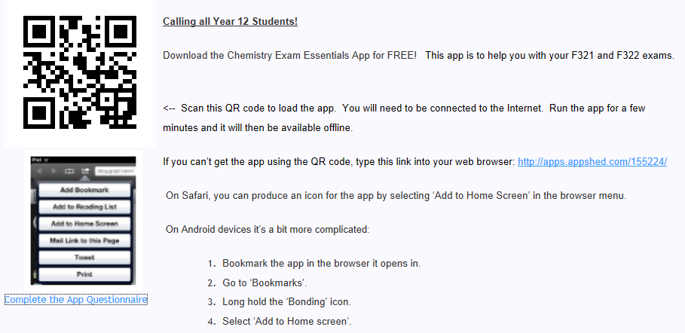
Alongside this app building project, Ian also wanted to trial electronic device based homework, in particular, web apps. It was thought that virtually every student would have access to powerful mobile devices such as smart phones and tablets and those that have not, would still be able to use the same web app on computers. The homework app shown below was produced for Year 11 GCSE students. Its purpose was to reinforce some basic facts and to counter reoccurring misconceptions. The app was designed using the Appshed Appbuilder tool, available free on the Appshed website.
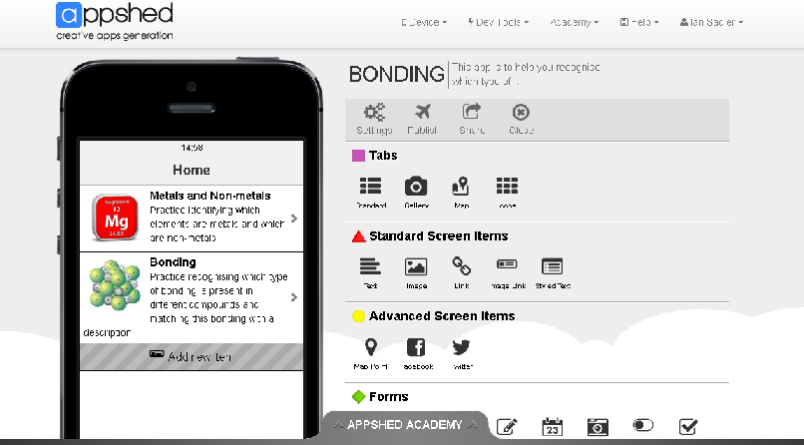
The homework was distributed on a slip of paper (see below) with descriptions of two methods of accessing the app; firstly an URL that could be typed into any web browser or a QR code (the square on the right) which could be scanned.
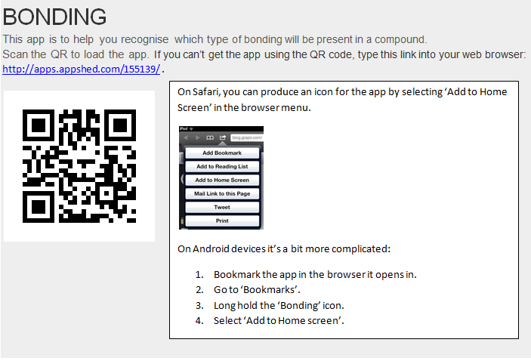
Students were told that if they do not already have a QR code reader on their device, the reader can be downloaded free from Google Play (Android) or the App Store (iOS). There were also instructions for creating an icon on the device so that the students may come back to the homework whenever they wanted to.
The app links students to external websites that host quizzes and surveys. It is also possible to link to YouTube videos, although students need to be connected to the Internet to access these websites. Once downloaded onto a device with an Internet connection, the app becomes standalone. The quizzes were designed by Ian using external websites.
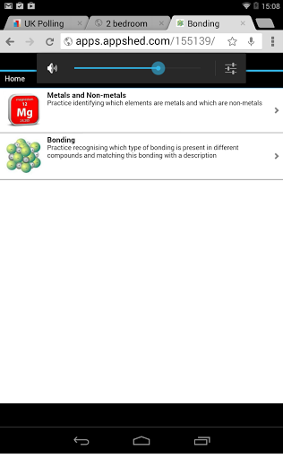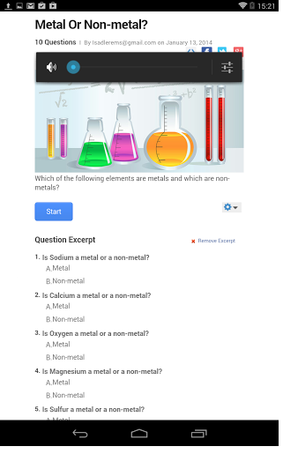
Screenshots of the Home page and of a quiz hosted by Proprofs.com on a Nexus 7 tablet
A similar app was then produced for Year 10 chemistry revision. Students were asked about the homework after a week. Ian decided that learning how to write in JavaScript may be beneficial so undertook the free online course with Codecademy. Christine also had a go but found it difficult translating this skill to building an app.
Christine then made an app for Year 13 Chemistry’s OCR F324 Revision which can be found at http://apps.appshed.com/223745/. Both of the KS5 apps were co-written by students who made puzzles to upload to the apps. They used Padlet to communicate with one another during the task. These apps can be considered working documents as they can be updated as students move through the course. Christine updated the link to the Year 12 app on the Chemistry website (www.emschemistry.yolasite.com).

3.1.2 Existing Apps

Stephanie initially wanted to investigate some existing apps to try out with students. She found some free iBooks and had a look through the Physics and Biology ones and thought that they were great. Christine agreed that the Chemistry one looked great too.
https://itunes.apple.com/gb/book/aqa-gcse-physics-essentials/id586622971?mt=13
https://itunes.apple.com/gb/book/aqa-gcse-chemistry-essentials/id586622959?mt=13
https://itunes.apple.com/gb/book/aqa-gcse-biology-essentials/id586622954?mt=13
However, the books went from being free to £3.49 each, so they were not downloaded. In fact it was noted that many apps that were free at the start of the project now have a small cost. It was decided that only free apps should be downloaded. Firstly, it was thought that a free Periodic Table app may be worth investigating. Periodic Table ! was one possibility, as was Periodic Lite. For Biologists, there were some great cell apps like HudsonAlpha iCell, https://itunes.apple.com/gb/app/hudsonalpha-icell/id364882015?mt=8 which was also free. For Chemists, there was a free app called goREACT which may have been worth investigating. Stephanie had already downloaded Science360 which has a range of free science videos and images.

Very early on in the project Ian found an app called Infection, in which users attempt to infect then kill the entire global population with a microorganism. This app was thought to be appropriate for both Year 8 and 9 students studying microbes and disease. Ian then identified a new app which he could use with his Year 9 class. In Energy Island by Siemens Education, users are responsible for providing the electricity to 5000 inhabitants and must power all the services for 24 hours both economically and without damaging the environment. Users learn about different ways of producing electricity and their advantages and disadvantages. Ian thought this was appropriate for the GCSE Physics course his class were studying. The students used the apps and then completed the questionnaire, the results of which are in the next chapter.
As all the students only completed the questionnaires in the lessons led by members of the science department there was no opportunity to fail to hand in, misplace or invalidate the questionnaires as the teacher could provide an appropriate amount of time and calm environment for the students to record their opinions. The teachers ensured that the students had time to consider their responses and ask questions if they did not understand what they had to do. The teachers also wanted to avoid “prestige bias” (Thomas, 2009, p.174) so explained to the students that their responses were anonymous if they wished.
Other features of the iPad such as the Safari browser and the camera were also investigated. Finally, an app called Educreations was trialled by both Yacine and Ian in their KS3 lessons. The feedback from these lessons can be found in the next chapter.
3.1.3 Developing a PLN
The first part of the development of the Personal Learning Network was the development of the website. Initially, this PLN was designed to host three case studies. Each case study focused on one ICT feature that will improve digital literacy in several of the DigiLit framework strands. Users could click on the projects for more information:
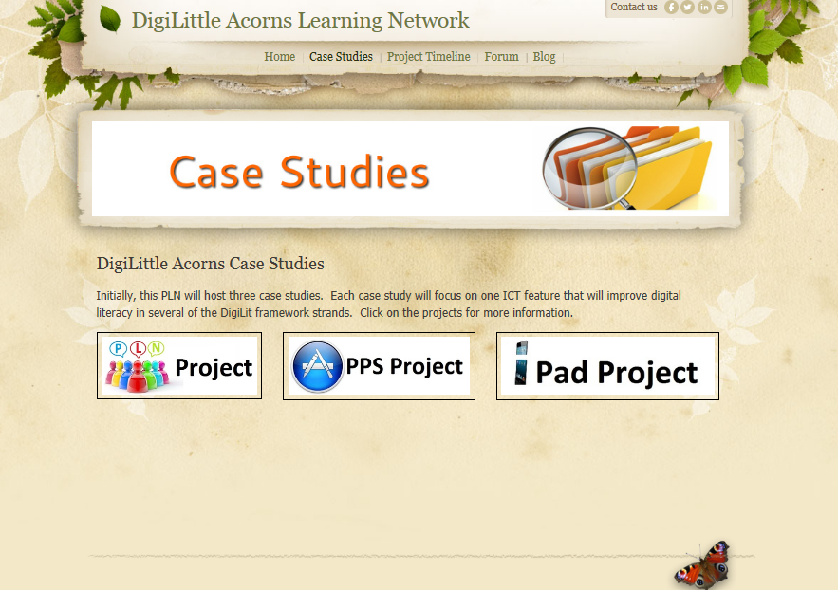
The project timeline was decided upon and uploaded to the website using Dipity.
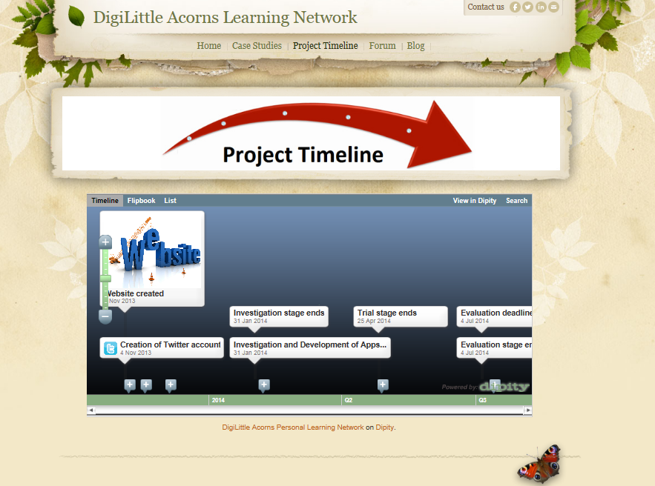
A forum was also added. This was in addition to the Facebook group as Facebook could not be accessed at school. The blog provided an opportunity to connect to anyone interested in the project and also helped when writing this report as it detailed the steps of the project in chronological order. The website was maintained by Christine throughout the project.
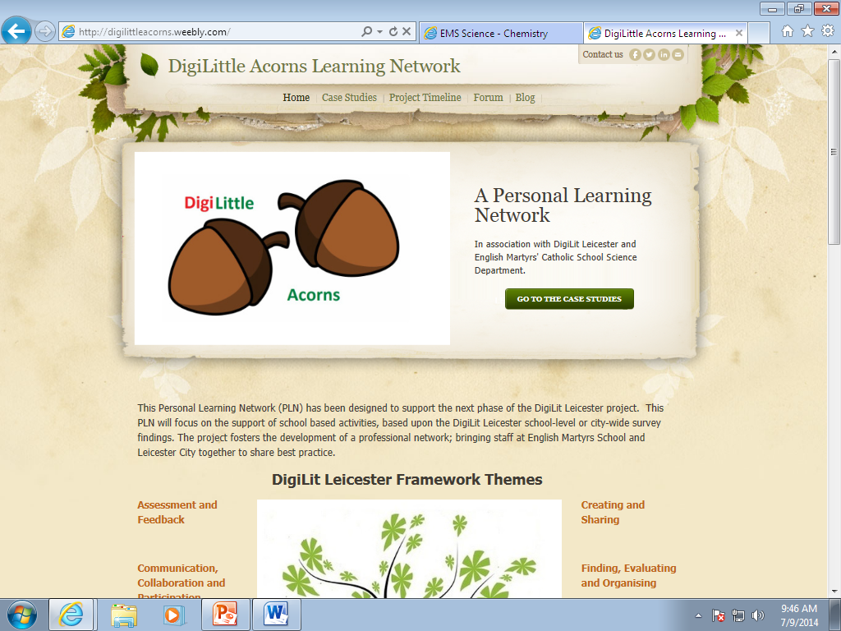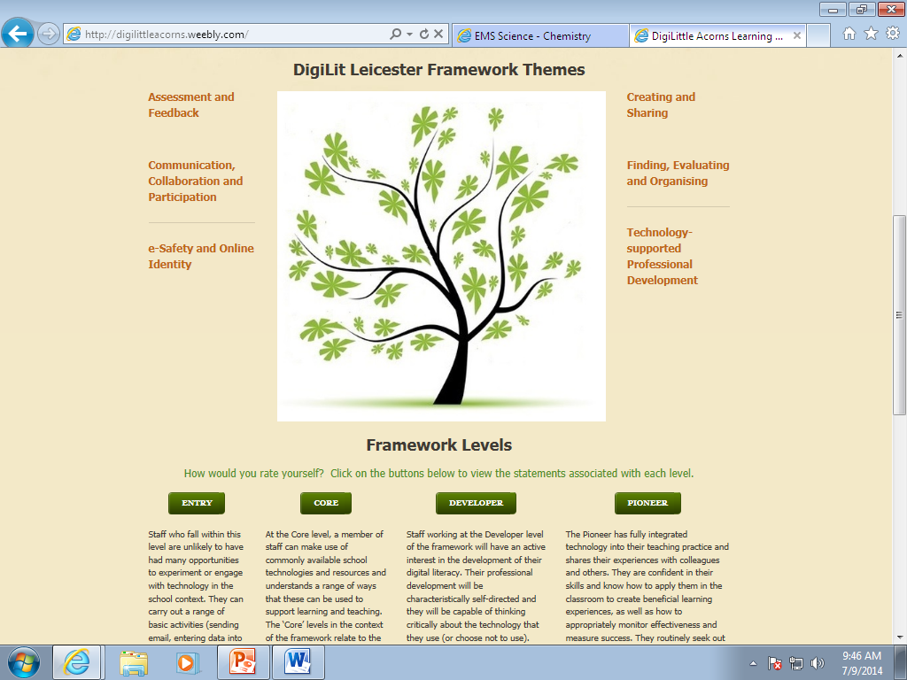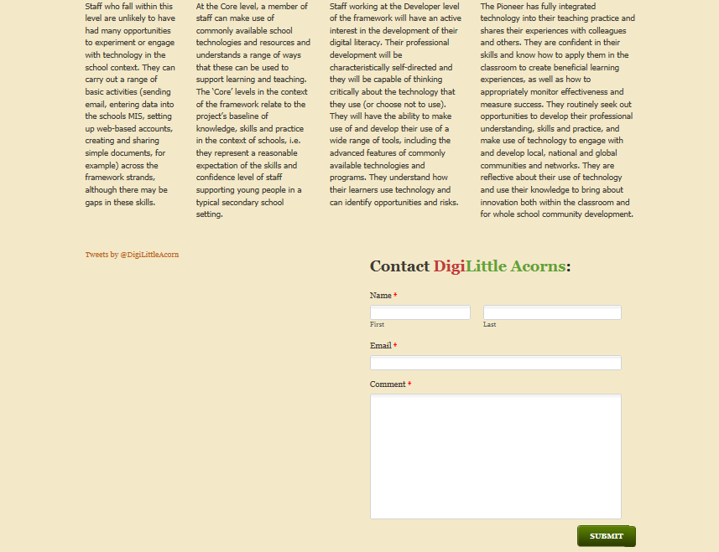
Christine planned to attend an event about Twitter for Educators on 5th March which she thought would be a good opportunity of networking and sharing the project with other staff in the city. She had previously created the @DigiLittleAcorn and #DigiLittleAcorns hashtag when tweeting about the project. After attending, Christine commented:
“I am now a twitter fan. I can reach teachers across the world and collaborate with them so easily now. I’ve even been able to automatically post my blog updates straight to twitter. I couldn’t do this before so I’ve definitely developed my digital literacy.”

CHAPTER FOUR RESULTS
4.1 Results
4.1.1 App building
Christine’s Year 12 Chemistry App
As of 19th February, 11 of her 16 Year 12 students had completed the evaluation of Christine’s Year 12 Chemistry app. 6 used an iPhone, and other devices they used included an iPad, Sony Xperia, Samsung Galaxy and iPod Touch. 10 of the 11 students reported no problems with making the app work but one student had difficulty saving it to the home screen.
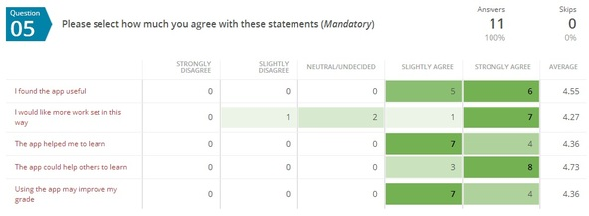
The students were very positive about the app. As can be seen above, they all thought it was useful, reported that the app helped them to learn and could help others to learn and thought using the app would improve their grade. Most students said they would like more work set this way (8 of 11 students).
The students were very helpful in describing other apps they would like to be developed. The comments were as follows:
"I think that the app should be produced for the other sciences as well as chemistry as it would prove a useful resource. For example, an app could be useful at helping students learn definitions in physics and biology as well as in chemistry. It is also useful to have a copy of the specification easy to access and this would apply to the other sciences as well."
"Apps would be very helpful to demonstrate different practicals and diagrams of models. Such as 3-D diagrams of molecules and bond angles in chemistry or diagrams of the blood movement in the heart linked to electrical stimulation and changes of pressure. An app could also be used for short multiple choice questions for short periods of revision without books."
"Within chemistry, other things could be added to the app such as different mechanisms and diagrams. Particularly with electrophilic addition and free radical substitution. Also, there could be practice questions in the app rather than just the specification. I think it would be helpful to have this sort of app in biology as well."
They also said the following in the "any other comments" section. Christine was surprised that they wrote so much as it was not mandatory to do so. One student said:
"I think the app is useful; particularly the definitions and specifications page. This is because, I personally lose marks on definitions, and an app where all my definitions are together is helpful, so I don't have to keep referring to the back of a textbook. Also, I think the specifications part is useful so we know how to answer questions, and I find the OCR website difficult to navigate around, so this app helps in finding what I need."

Ian’s Bonding App
These are the results of Ian’s questionnaire:
Difficulties attempting homework?
No problems | Could not load | Could not save |  | Did not work on device |  | External website did not work |  | Other
12 | 0 | 0 |  | 2 |  | 3 |  | 2
Samsung x 3  iPhone x 6  Computer x 2  iPod x 1 |  |  |  | iPhone x 1  iPod x 1 |  | iPhone x 1  iPod x 1  iPad x 1 |  | Adverts got in the way (iPhone)  Just not clear enough (iPhone)
More app homework?
Yes |  |  | No |  |  |  | Don’t Mind
6 |  |  | 3 |  |  |  | 7
Was it useful?
Not at all |  |  | Very little |  | Quite a bit |  | A lot
1 |  |  | 5 |  | 9 |  | 1
Other comments
Very good x 2; Good stuff; Great app; The app could be better designed and the questions more challenging; Improve app – make actual app

Most students did not experience any problems, although the external websites failing to work was an issue. This concern was what prompted Ian to learn how to code using JavaScript.

4.1.2 Existing Apps

As part of her own personal development, Steph investigated the following apps and recorded their use in the table below:

App Name | Year Group | Subject | Possible use
Calculator | All | All | Any lesson involving numeracy
ShowMe + Educreations | All | All | Presentation tool – best for students to produce a quick presentation which can incorporate photos and other media e.g. human body model or circuits
Formulas Lite | 12-13  12 | Chemistry  Chemistry | Identifying homologous series  Teaching names of polyatomic ions
Nova elements | 9-11 | Chemistry | Allows students to build atoms; teaching electronic structure and the Periodic Table
Cell Stain | 12-13 | Biology | Allows students to stain their own cell in order to visualise organelles
Physical Science Glossary | All | Physics | Contains flashcards and videos of physics concepts and vocabulary
Visible Body | All | Biology | Contains 12 excellent quality free videos showing how the human body works
AtomsHD | 9-11 | Chemistry | Allows students to build atoms; teaching electronic structure
Planets | 7-11 | Physics | Shows appearance of planets and location of constellations in the night sky
Jurassic | 10  8 | Chemistry  Geology | Teaching students about Pangaea  Shows sedimentary rock formation
Xperica | 9-11 | Physics | Contains 4 physics experiments –moments, heat capacity, resistance and oscillations from which students can collect data
Chem Spider | 12-13 | Chemistry | Shows how to draw organic molecules
iCell | All | Biology | Teaching students cell structure during topics 7A and 8C
Mitosis | 12 | Biology | Teaching different stages of mitosis. Contains videos and tests.
Infection | 7-9 | Biology | Teaching students about the spread of infection, pandemics and vectors
Siemens Energy Island | 7-10 | Physics | Teaching students about the different methods of electricity generation and resources
Half Life Hero | 11 | Physics | Teaching students about uses of radioactive isotopes

Results of the Energy Island app
Ian decided to ask the students to give some written (open ended) feedback for this app. The students were asked to point out flaws in the electricity generation and use model the app uses. Their comments are listed below:
“You didn't see the size of the city. It didn't represent seasons, so in winter more people will be using heaters and lights whilst in summer people will need less heaters and lights on at night.”
“The resources don't run out so quickly in real life. The game seemed biased to renewable energy.”
“I think that the flaws were that there weren't different seasons as the amount of energy produced could be determined by the weather. It was also biased as the most energy was produced by things that produced renewable energy.”
When asked how they would improve the app the responses were:
“Use different scenarios for the seasons. It didn't show clearly that the renewable resources don't...” (unfinished)
“The app could use numbers and measurements instead of bars.”

Results from a variety of groups using the Infection app

8 Ward – mixed ability – Observations from a Core colleague (Carolyn Watson)

“I had just completed the 8C topic with a group and thought that the Infection application would be a useful conclusion. This would bring together previous learning and introduce the concept of how easily an infection could spread globally. The lesson began with a revision starter of what is a pathogen, list examples of pathogens and how diseases are spread. This was a group work discussion and then class discussion.
I introduced the concept that they were in charge of the mode of infection and some individuals tried to find out how quickly they could infect the world population. The students were excited about using the iPads and very patient while I went through the protocol of rules together with handing out the iPads to each individual.
Two students had played a similar Plague type game so were able to assist others that had not met the game before. No student had any problems finding the programme and all were on task and totally absorbed in the tasks involved in the game. All students took great delight in trying to achieve world infection until it was found that the scientists were catching up and finding a cure.
They then asked me what ‘evolve’ meant and at this point I briefly stopped the class to share mutation of bacteria. After this discussion the students were off trying to again beat the world. A number of new learning concepts and discussion points were raised with the process of the game. The students had not appreciated how microbes can quickly mutate and thus ruin the scientific work that had previously been undertaken a particular organism.
The word ‘vector’ was introduced by the game and I asked the students to think up a definition and then vote on the best definition. This led to further discussion and questioning of the student about the examples of vectors given in each individual’s game.
Needless to say the students enjoyed the lesson immensely and wanted to ‘play’ again next lesson. All students were on task and totally absorbed in the activity. The activity led to much discussion and a small amount of board work namely identifying key words and definitions. The students were supportive of each other and assisted their neighbours with finding the ‘evolve’ options. There was also an element of competition and curiosity for each other and frequent asking of how many of each other’s population had been infected.”

8 Campion – mixed ability

Christine used the Infection Bio War app to teach her class about how diseases can spread (epidemics, pandemics and vectors). The students were allowed to use the app for 20-30 minutes and then had to complete a worksheet which asked them scientific questions about microbes. At the end of the lesson, all 30 students completed the short questionnaire. Here are the results:

Q1
Did you enjoy using the iPads?
Not at all | 0
Very little | 0
Yes, quite a bit | 1
Yes a lot | 29
Q2
Did you learn much from the iPad activity?
Not at all | 0
Very little | 0
Yes, quite a bit | 17
Yes a lot | 13
Q3
Do you think you learned more than in a 'normal' lesson?
Much less | 0
A bit less | 3
A bit more | 16
Much more | 11
Q4
How easy was the app to use?
Very difficult | 0
Difficult | 0
Easy | 7
Very Easy | 23

The students enjoyed using the iPads a lot. All students thought that they learned from the app, and most thought that they learned more than in a normal lesson, although some students thought otherwise. All students said that the app was easy or very easy to use. No additional comments were made. This was a challenging class who behaved very well when using the iPads for the first time.

8 Clitheroe – mixed ability

Ian used the Infection Bio War app to teach his class about how diseases can spread (epidemics, pandemics and vectors). The students were allowed to use the app for 20-30 minutes and then had to complete a worksheet which asked them scientific questions about microbes. Again, at the end of the lesson, all 30 students completed the short questionnaire. Here are the results:

Q1
Did you enjoy using the iPads?
Not at all | 0
Very little | 0
Yes, quite a bit | 0
Yes a lot | 30
Q2
Did you learn much from the iPad activity?
Not at all | 0
Very little | 0
Yes, quite a bit | 9
Yes a lot | 21
Q3
Do you think you learned more than in a 'normal' lesson?
Much less | 0
A bit less | 1
A bit more | 10
Much more | 18
No response | 1
Q4
How easy was the app to use?
Very difficult | 0
Difficult | 0
Easy | 7
Very Easy | 23

The students enjoyed using the iPads a lot. All students thought that they learned from the app, and most thought that they learned more than in a normal lesson, although some students thought otherwise. All students said that the app was easy or very easy to use. In addition, the students made the following comments:
Good to use, easy to use.
It made the lesson more fun about learning about microbes.
They were good to use and have a change of lesson plan.
I learned a lot about transmissions and symptoms to creating a disease.
It was more interesting using the iPads than a normal lesson.
It was very fun.
Very good (twice)
Very fun! (twice)
again again
They were easy to use and also fun.
I love iPads!
The lesson was very fun.
The interactive learning helped me visualise the disease spreading.
It was awesome!!! Using the iPads were awesome!
Hope we can do it again!
That was awesome.
It was a lot more interesting than usual.

The comment "The interactive learning helped me visualise the disease spreading" was an indicator that even though marketed as a game, this app was educational and a good choice for this mixed ability group.

8 More – mixed ability

Steph completed the Infection app activity with this Year 8 smaller group:
Q1
Did you enjoy using the ipads?
Not at all | 1
Very little | 0
Yes, a bit | 3
Yes a lot | 18
Q2
Do you learn much from the iPad activity?
Not at all | 0
Very little | 1
Yes, quite a bit | 7
Yes a lot | 14
Q3
Do you think you learned more than in a 'normal' lesson?
Much less | 0
A bit less | 3
A bit more | 6
Much more | 12
Q4
How easy was the app to use?
Very difficult | 0
Difficult | 3
Easy | 8
Very Easy | 10
Other comments:

Does not waste ink and paper, helps environment. Very cool, I want to download the app, we should use them a lot more.
I didn't understand the game.
Doesn't waste ink, saves a lot of trees. Q4 - hard to start off with, but very fun. I may download it at home. I thought that it was fun and I enjoyed it a lot. I don't think it was hard to use. Downloading it at home! It was fun and also I leant something. There was lots of information around diseases. I enjoyed the game a lot, it was fun and I learned from it. I thought it was a good/fun way to learn. x3
I loved using the iPad, it was more interactive than having a lesson.
Amazing lesson, love to use it again.
I really enjoyed using the iPads because school is usually boring, but by adding iPads to a lesson everyone is having fun, whilst learning.
I loved using it. x2
It was a nice change not writing in books.
It is a fun way to learn, definitely downloading at home. x2
Very fun and easy to use. I want the app on my phone.

9 More – mixed ability

This year 9 group also enjoyed using the Infection app with Stephanie:

Q1
Did you enjoy using the iPads?
Not at all | 0
Very little | 0
Yes, a bit | 6
Yes a lot | 20
Q2
Do you learn much from the iPad activity?
Not at all | 0
Very little | 2
Yes, quite a bit | 5
Yes a lot | 19
Q3
Do you think you learned more than in a 'normal' lesson?
Much less | 1
A bit less | 4
A bit more | 9
Much more | 12
Q4
How easy was the app to use?
Very difficult | 0
Difficult | 1
Easy | 10
Very Easy | 15

Other comments:
I enjoyed it so much, I think we should use it more often and I found out a lot of things. It was good fun. x4 :-)
Should use them more often. x3
You focus more on an iPad.
It was a great experience.
It's fun and the game is easy to use. You can learn lots of things on an iPad.
It was great and I learned so much.
I learned much more on this than in a normal lesson & I enjoyed it.
It was really easy and fun to play.

9 Sherwin – mixed ability
9 Sherwin used the same app that Ian trialled with his Year 8 class. Here are the results:
Q1
Did you enjoy using the iPads?
Not at all | 0
Very little | 0
Yes, quite a bit | 2
Yes a lot | 24
Q2
Did you learn much from the iPad activity?
Not at all | 0
Very little | 0
Yes, quite a bit | 8
Yes a lot | 18
Q3
Do you think you learned more than in a 'normal' lesson?
Much less | 0
A bit less | 1
A bit more | 12
Much more | 13
Q4
How easy was the app to use?
Very difficult | 0
Difficult | 0
Easy | 11
Very Easy | 15
Other comments:
Different types of learning. It's fun to play a game in class. It's unique and we're more likely to learn as we are enjoying the lesson even if we were just researching on the iPad. Good to challenge friends. Amazing. Great!! Great fun. It was useful. It was fun and educational. They make learning a lot more enjoyable. I felt I learned what a vector is. Learn more as it's interactive.
Learnt a lot about vectors and disease transmission. I learnt how microbes can spread. I learnt that people can be infected by a lot of things. I found out how countries try to fight against diseases. It's a really good way of learning. I know what a vector is. How they can spread very quickly. I learned how diseases spread. It is easier using more new technology. I learnt all about the infectious diseases. Instead of writing about stuff in a lesson, we visually saw what sort of effect it had on the world and how everyday things can affect infection. I learnt the details of a vector.
Helps lots. I don't concentrate very well but today I did. I learnt things about DNA. I actually did, I would say about the same. You understand what the bacteria would do and what the world would do. It was more interactive. It engages everybody. I learned more than usual. We learn while we play.
Scientific information learned: The spread of diseases. I learnt that a vector is a carrier that transfers an infective agent from one host to another. What a vector is. How different symptoms affect people more. What we can do to be resistant to it. I learnt more about how governments try to cure diseases and what they do to cure it. Airborne and water is how microbes are spread. Vectors and disease spread. Diseases can be spread easily. What a vector was.
I didn't get it at first but I love it. When you get used to it was easier. It was hard to understand what to do when we started. They are simple and fun. After some getting used to, it is a lot easier. Easy, simple and basic. It was confusing at the beginning but then I got it. I would prefer easier instructions.

The students indicated that they enjoyed using the iPads. This was visible in the lesson; all were highly engaged. It was pleasing to note that although a game, the students felt that they learnt from using the app, with 25 indicating more than in a 'normal' lesson. Most said the app was easy to use - though some found it challenging for the first minute or so whilst they worked out what they could control.
10Y1 – higher and middle ability
Steph used the infection app with one KS4 class too:
Q1
Did you enjoy using the ipads?
Not at all | 0
Very little | 0
Yes, a bit | 4
Yes a lot | 16
Q2
Do you learn much from the ipad activity?
Not at all | 2
Very little | 0
Yes, quite a bit | 9
Yes a lot | 9
Q3
Do you think you learned more than in a 'normal' lesson?
Much less | 2
A bit less | 5
A bit more | 4
Much more | 9
Q4
How easy was the app to use?
Very difficult | 1
Difficult | 0
Easy | 6
Very Easy | 13

Other comments:
The iPads are good but wouldn't want to play games.
Today's lesson with the iPads was really good and more interesting than a normal lesson. I learnt quite a lot and had fun doing it. I really enjoyed using the iPads and it also helped me learn about diseases etc. Really enjoyed the use of the iPads because it was different, it also showed me different ways of learning! I learnt things a lot quicker, I think.
I really enjoyed this lesson using the iPads because it was interactive and interesting. Very good and useful.
Slow app, but more interesting than normal lesson.
Good but was getting boring. It was a more enjoyable way of learning and most of us know how to use them already, making it easier. I found it more enjoyable than 99.9% of my lessons.
9 Sherwin’s use of the iPad camera

Christine used the Camera and Safari apps with her Year 9 class. In the previous lesson, they had been taken to the computer room, in order to access the website www.9sherwin.weebly.com which instructed them to find out about MRSA and write a TV or radio script which answered a set of questions, given on the site. They worked in groups of up to 4 students to compile their scripts. Some finished them off at home, where they could still access the website.

In this lesson, the students accessed the website again, using Safari, to gather any further information. They then edited their scripts and recorded them using the video option on the Camera. At the end of the lesson, some of the videos were shown and feedback was given to the groups by both the teacher and students. The students then completed the questionnaire, the results of which are shown below:
Q1
Did you enjoy using the iPads?
Not at all | 0
Very little | 0
Yes, quite a bit | 0
Yes a lot | 17
Q2
Did you learn much from the iPad activity?
Not at all | 0
Very little | 0
Yes, quite a bit | 6
Yes a lot | 11
Q3
Do you think you learned more than in a 'normal' lesson?
Much less | 1
A bit less | 4
A bit more | 6
Much more | 6
Q4
How easy was the app to use?
Very difficult | 0
Difficult | 1
Easy | 2
Very Easy | 14

The students enjoyed using the iPads a lot. All students thought that they learned from the app, and most thought that they learned more than in a normal lesson, although some students thought otherwise. All but one student said that the app was easy or very easy to use. In addition, the students made the following comments:
I got to have fun and get some work done.
By listening and reading I got a lot of info I did not know.
I enjoyed it.
It is very fun and different to be doing something else and more fun in lessons.
I learnt to speak under pressure of the camera where I wasn’t very comfortable. (Explanation of why they said they learned a lot)
We weren’t concentrating on the lesson as much as we were concentrating on the video. (Explanation of why they said they learned a bit less than in a normal lesson)
The app is not hard at all.
We got all work done.
We just recorded. (Explanation of why they said they learned much less than in a normal lesson)
I love using iPads in lesson.
Yes but not as much as from Miss Turner. (Explanation of why they said they learned quite a bit)
Sometimes the apps ran a bit slow and didn’t connect to the Internet, otherwise great.
It was interesting.
I enjoyed the change.
It was good to search for stuff I am uncertain of.
I liked it more so I learned more.
It was easy to use because I have one at home.
It was easier than using cameras and more efficient.
There’s even a game about how things can be infected e.g. through airports.
It’s just tapping so you can get more done.
Very fun.
Very fun and entertaining to use.
Engages our interest. Interesting to use.
I found this lesson fun.
I learned a lot.
I was always able to get right to the information I wanted.
Very fun to use.
Easy to learn how.
More enjoyable.
Everyone knows how to use them – very easy.
We got work done and enjoyed doing it.
We were able to create a game show on MRSA.

From the teacher's perspective, after an initial 'play' (students taking pictures of themselves and opening random apps, such as the dictionary), the students soon got down to recording their scripts. They were able to have several 'takes' and delete any they were not happy with. Some decided to record in short segments so produced a few clips. This was useful because if they made a mistake, they only had to re-record a short section. Being able to access the website from anywhere in the classroom was useful. Some wrote their script on their iPad using the Notes app, and some read short sections from various websites, whilst adding their own opinions too.
The problems the teacher encountered were that recording 5 or 6 videos in the same lab was a little difficult, as it was a loud environment. Some students wanted to take their iPad outside (which, for a first use the teacher thought perhaps not) to overcome this, which was a reasonable request. One group went out with the TA and produced a very clear video with good sound quality. When playing the video back to the class, it is essential that the iPads are plugged into some speakers as they were only 'just' loud enough to hear. The class were absolutely silent during play back so they could hear, which the teacher thought showed good respect. The iPads all came back in one piece. Some thoughtful students had closed any apps they had used and deleted anything not needed, though not all had done this. It is recommended that the teacher leave time to do this at the end as it will preserve the battery and not clog up the Camera Roll. It should be noted that this lesson was held on a Friday, lesson 5 (1.45pm - 2.45pm) of the penultimate week before Easter and the teacher was impressed that the students behaved so well.

7 Fisher’s use of Educreations, the camera and other apps

Yacine used the iPads in several ways during a revision lesson on the Electricity topic. Firstly, students used both the Serial bulbs lite app to make a series circuit and answer the questions. Unfortunately the app did not work on all the iPads - about 5 would not load correctly. Then students made some series and parallel circuits in groups, took photos of them using their iPads and discussed the circuits they had made, and then tried to draw their circuits using Educreations. This app worked well on all the iPads. Some students brought their circuit drawings up to the interactive whiteboard to share with the class. The teacher could ask the students questions about the circuits and the students used Educreations as a mini-whiteboard to show their answers. Taking photos of the circuits encouraged students to arrange them neatly and check they had made the circuit correctly. All students were focused and treated the iPads with great respect. They all looked like they were enjoying the lesson too. All 28 students agreed! They also found the iPads easy to use.

Q1
Did you enjoy using the iPads?
Not at all | 0
Very little | 0
Yes, quite a bit | 0
Yes a lot | 28
Q2
Did you learn much from the camera activity?
Not at all | 2
Very little | 3
Yes, quite a bit | 7
Yes a lot | 16
Q3
Did you learn much from the other apps?
Not at all | 2
Very little | 1
Yes, quite a bit | 12
Yes a lot | 13
Q4
Do you think you learned more than in a 'normal' lesson?
Much less | 0
A bit less | 3
A bit more | 9
Much more | 16
Q5
How easy was the app to use?
Very difficult | 0
Difficult | 1
Easy | 5
Very Easy | 22

No additional comments were made. Students enjoyed all the activities though some reported some of the apps didn’t work as well.

4.1.3 Developing a PLN

As there are no results as such from this section, comments from colleagues can be found in the next chapter.

CHAPTER FIVE DISCUSSION AND CONCLUSIONS

5.1 Research Questions

The research questions were as follows:

- When considering the use of iPads in lessons, do students find them a) easy to use b) fun to use and c) able to be used as a tool for learning?
- When considering the use of Appshed to build apps, do developers find it easy to use and do users find the apps made a) easy to use b) fun to use and c) able to be used as a tool for learning?
- When considering the development of a Personal Learning Network, which tools support this and what are the benefits?

5.1.1 App building

Over the course of this project, Ian and Christine have successfully learned to produce apps using the Appshed app building tool, by watching the Appshed channel on YouTube. The apps produced were used with Year 10 and Year 11 Chemistry classes as homework and with Year 12 and 13 Chemistry classes both in class and at home. Ian has also supported a teacher in another school (T. Wint, at Uppingham Community College) in learning to produce an app. This teacher went on to provide whole school training to her staff. The PowerPoint she used is below:

The apps Ian produced used websites such as Surveymonkey and Proprofs as hosts for quizzes. Ian agreed that this was unreliable and commented:

“This was something I had not tried before. I found there were some compatibility issues with some devices on this websites and that the devices having to be online to access them is a limitation. I decided that to make an offline app, I would need to learn to code in JavaScript. Using Codecademy, I am at the stage where I intend to produce an offline app before the start of the next school year.”

Overall, when considering the use of Appshed to build apps, the developers found it easy to use if a little cumbersome. The users found the apps that were made easy to use, but perhaps could be made more fun to use if flash was enabled. The apps, however were able to be used as a tool for learning and received many positive and encouraging comments from students.

5.2 Existing Apps

Several Year 8, 9 and 10 classes trialled the Infection app with very positive outcomes. All the results from the questionnaires can be viewed in the previous chapter. The teacher would use this app once with each class studying disease transmission, vectors and mutations. As it was a free, offline app, it worked well even with slow wi-fi and cost nothing to download. Overall it was viewed to be a fun, educational game.

Carolyn commented:

“I found that initially there was a lot to remember to say to the students and dealing with getting the equipment out and returning to the right place but could possibly introduce iPad monitors along with the book monitors maybe to speed up the process. I very quickly felt at ease and comfortable with this lesson and felt the students enjoyed the game. They had also understood many key concepts of how diseases are spread, mutation and the history of how the plague started in the village of Eyam, Derbyshire (our last discussion and bringing real life examples into the topic).”

Ian also commented:

“Infection was actually suggested to me by a Year 8 student. I also found Energy Island and Half life Hero and I was the first to use these with classes.”

Year 7 classes trialled the Educreations app with some success. It seems to be a free version of 'Paint' and turned iPads into mini whiteboards without the mess. Students found them easy to use and when connected to the interactive whiteboard allowed students to show the whole group what they had produced. It was viewed to be a good, free, offline app and the teachers thought that they would use this regularly. Towards the end of the project, Ian had started to use Educreations regularly with classes although there were problems with the network connection which meant that the students found it difficult to find the research sources they needed.

Ian commented: “Some students overcame this by using iTransfer to share files - teaching me how to do this at the same time!”

Unfortunately there were some problems with the Serial Bulbs Lite app. Several students reported that it would not load. Also, although advertised as a free app, there is very little for students to do before they needed to make an in-app purchase. The teachers said they would not use this app again. Christine commented:

“I helped to lead Yacine’s lesson when the Year 7 group were using this app. It was really frustrating as about a third of students experienced the app crashing. This is clearly a problem with some free apps. They need to be robust or they can throw the whole lesson. Good job there was a back-up plan!”

Ian used the Energy Island app with a Year 9 class. Although not necessarily true to life, the app worked well, and like Infection, it was a free, offline app. This definitely seems to be the way forward when the school's wi-fi signal is poor (as ours will be until the new build is finished). The higher-achieving students were asked to evaluate it and were quite critical of the app. It may have some value when investigating energy resources as an aid to promote discussion.

The camera feature is quite a powerful use of the iPad. Despite concerns of students taking 'selfies', the students who have used the camera in lessons have largely done so to record their work. Christine thought that it was really useful at times to capture a piece of work or experiment set up and used this regularly; connecting her own iPad to the whiteboard. Christine thought that she would use this feature regularly in lessons both to demonstrate something and with the students, commenting:

“The best part of this lesson, for me was when I observed a group of lively Year 9 boys using one iPad to read a script from; another quickly researching on Safari and another filming all using their iPads at the same time for different tasks. I would recommend buying a VGA to Lightning connector so the iPads can be easily connected to the whiteboard or computer, as it was good to watch their movies at the end of the lesson.”

Although we have not really used the iPads for browsing, it is worth noting that with a good wi-fi signal, researching a topic becomes simple with the iPads and the Safari browser. No more having to book the elusive computer rooms, perhaps! It also allows students to research and complete an experiment in the same room. Teachers said that they would regularly use this feature.

A much improved version of Wallwisher. Christine used Padlet with Years 12 and 13 in order to share resources very effectively. The level of control the user has is good, and the list feature means that post-its are not deleted or moved as easily. Christine thought she would definitely use this again as it would be great with all the students contributing on their own iPad as long as the wi-fi was working!

The iPads have been a fun, engaging and useful tool to use in lessons. Overall the teachers thought that this project has been a positive experience. Steph commented:

“I felt quite nervous about getting the iPads out with classes to start with, even with sixth form students. After using them several times with a wide range of year groups (8, 9, 10, 12), I feel much more confident about the use of technology within the classroom and being able to manage this. There was very little inappropriate use and students were extremely responsible. The use of the booking system with numbers and names was useful and made students accountable for their iPad.”

She also noted that:

“It was fantastic to get the iPads out with classes; they engaged students and they were very quiet and attentive! The activities that followed the iPads being collected in e.g. worksheets were done much more efficiently than usual.”

On a final note, it is unfortunate that there are not more free Apps to use in lessons. Many of the Apps have free aspects, but to get the full use you need to pay for this. This could be overcome if teachers were able to make their own apps, as shown in this project.

5.3 Developing a PLN

Christine managed the project and maintained and moderated the Facebook group, Twitter feed and the website, as well as writing all the blog posts and learning how to use Appshed so she could help other staff members should they have encountered any issues. She also liaised with others in the purchase of the equipment. In addition to this, the ICT department supported Christine with managing the project. Firstly they obtained three quotes for iPads, the Mac Book Pro (which we need to update and control the iPads) and the Charge & Sync trolley from several companies e.g. Apple Education, Misco, JP UK. The cheapest was JP UK. They placed the order and after a short time took delivery of the iPads and the Mac Book Pro. The trolley took longer to deliver. Once everything arrived, they set up all the iPads for use so we could start using them with the students. They also logged all the purchases so we could keep tabs on what we bought.

Two main connections with other schools have been made during this project. Firstly, there has been some networking with Rushey Mead school’s science department who are currently investigating whether they could use the iPads which exist in the school (but not specifically in their department) to enhance science lessons. The email from Nisha Kholia can be seen below.

Dear Christine,
Many thanks for your time today and sharing best practice for using iPads in science lessons. The apps created that you shared today with your students was extremely beneficial along with effective existing apps that could be incorporated into science SOWs. It proved to be an invaluable opportunity to review, reflect and evaluate the effectiveness and impact of iPads as an innovative T&L tool. The feedback and apps shared from today’s meeting will be disseminated to my colleagues and SLT at Rushey Mead School. Hopefully we are able to network more frequently and share good practice regularly once our department receives a class set of iPads.
Thanks again
Take care
Nisha Kholia
Specialist Lead Teacher: Teaching and Learning

Christine hopes to continue to share best practice with her in the future. Secondly an app share has taken place between Uppingham Community College, who kindly allowed us to use their app: http://apps.appshed.com/158403/ and have been trying out ours in return. This was an effective partnership set up by Ian. In addition, the Twitter account has gathered some followers from across the city, for example @LessonToolbox.

Christine felt that this project has also been successful in developing the digital literacy of her colleagues. Carolyn especially, who was at core level before, provided the following feedback:

“Within topic 8D and AQA GCSE Biology (pollution indicators) there is a need to show students field work activities of pond dipping and how sampling of polluted water is carried out. I have in the past shown water samples that have been made up in jam jars to represent different levels of pollution. Students have been given laminated cards of water invertebrates and asked to suggest which types of organisms can be found in which water type. I now plan to research the possibility of an application to cover this topic so that it can be incorporated maybe in a game involving man’s pollution of a water course and later recovery.”

Stephanie, who described herself at Developer level at the start of the project now considers herself to be a Pioneer in this field, commenting:

“I think I have now developed the following Pioneer skills by doing this project:

- I am able to demonstrate the effectiveness of my teaching methods and approaches through the use and analysis of a range of data.
- I can recognise when elements of the curriculum are best approached by my learners working collaboratively through technology.
- I understand the importance of modelling the positive use of technologies for young people and I do this in a range of ways.
- I understand how to identify, manage and address the risks associated with learning and teaching in a range of online environments.
- I keep up to date with the wide range of online, mobile and gaming technologies young people use and the key ways in which they use them.”

With regarding Ian’s progress, he reported that he had not used social media in a work situation before, but now he has used a Facebook group to share information and progress about this project, which he found to be a very effective way of communicating quickly. He also thought that it was useful that you could see who had read the comments. Ian has also moved from Developer level to Pioneer and is looking to share his knowledge of developing resources for mobile devices with other members of staff next year.

Carolyn, who placed herself as a Core user felt positively too:

“Looking at the categories of level of user I would happily place myself at core level. I did not have an iPad until I was presented with one from the department. At the beginning I was like a kid with a new mobile phone and started by how I switch it on and then finding that it was similar to the mobile phone but larger! Firstly I worked with a friend who has an iPad and a happy afternoon was spent finding my way around the applications. I must admit to getting a little side tracked with the different concepts of the mirrors and wondered if that would be useful in a drama setting! However I found the concept of being able to allow students on their own personal voyage of discovery, very exciting. I was particularly taken with the clarity of the biology photographs and the chemistry molecular models. This application would be really useful for the year 8 topic where elements, mixtures and compounds are researched. We also have a year 8 homework project that can lend itself to building a molecule, so again this application would be useful.”

As an addendum, it should be noted that two members of staff left the department (for pastures new, or on maternity leave) during the course of this project and so have not been consulted during the evaluation.

  - Conclusion

To summarise, this project reports that when considering the use of iPads in lessons, students find them easy to use, fun to use and able to be used as a tool for learning. When considering the use of Appshed to build apps, developers find it easy to use if cumbersome and users find the apps made easy to use, and able to be used as a tool for learning. There is much scope for building better and more fun apps. When considering the development of a Personal Learning Network, tools support this are Twitter, Facebook, blogs and websites and the benefits of these are increased communication opportunities with colleagues inside and outside school, and across the city.

This study, unfortunately, has many limitations. The limitations are concerned with confidentiality, type of sample, validity and reliability. Firstly, and unavoidably, the researchers taught all of the students who participated in the study. Therefore the results may be subject to bias as the students had direct contact with the researchers, who were always present during the data collection. Secondly, as with the research conducted by Brodahl et al. (2011) this study was conducted with small opportunistic samples. The maximum group size in this study was a class of 30 students which is small for a study of this breadth. There may be benefits to conducting a similar study with larger groups of students in several different types of establishment.

It is thought that an initial expansion of the project to a whole school initiative could provide more evidence for the success of the apps and iPads, as larger numbers of participants would be involved and may also show if they are able to be beneficial to students studying subjects other than science. Indeed, it may be interesting to investigate if students in deprived areas make more progress if these technologies are made available to them on a regular basis.

Although a greater amount of measurement validity has been ensured by the triangulation between numerical data and qualitative responses, this study has a lower external validity because clearly this study cannot be generalised to other schools. Nevertheless, great potential remains for the individual teacher to improve teaching and learning on a smaller scale by using free apps and iPads, providing the teacher can use them effectively, make the apps attractive and easy to use by students and have time to plan and embed the iPad activities into the teaching sequence appropriately.

References

Brodahl, C., Hadjerrouit, S. & Hansen, N.K., 2011. Collaborative Writing with Web 2.0 Technologies: Education Students ’ Perceptions. Journal of Information Technology, 10 (Innovations in Practice), p.2010. Available at: <http://jite.org/documents/Vol10/JITEv10IIPp073-103Brodahl948.pdf> [Accessed 9 July 2014].

Byron, T., 2008. Safer Children in a Digital World. The Report of the Byron Review. Nottingham: DCSF Publications. pp.1-226. Available at: <http://media.education.gov.uk/assets/files/pdf/s/safer%20children%20in%20a%20digital%20world%20the%202008%20byron%20review.pdf> [Accessed 9 July 2014].

Enonbun, O., 2010. Constructivism and Web 2.0 in the Emerging Learning Era: A Global Perspective. Journal of Strategic Innovation and Sustainability, 6(4), pp.17-27. Available at: <http://www.na-businesspress.com/JSIS/EnobunWeb.pdf> [Accessed 9 July 2014].

Fox, M., Martin, P. & Green, G., 2007. Doing Practitioner research. London: Sage.

Ofcom, 2011. UK children’s media literacy. Research document, Ofcom [online], April 2011. pp.1-104. Available at: <http://stakeholders.ofcom.org.uk/binaries/research/media-literacy/media-lit11/childrens.pdf> [Accessed 9 July 2014].

Ofsted, 2014. Available at: < http://www.ofsted.gov.uk/inspection-reports/find-inspection-report/provider/ELS/120306> [Accessed 9 July 2014].

Prensky, M., 2001. Digital Natives, Digital Immigrants, Part 1. On the Horizon, 9(5), pp.1-6. Available at: <http://www.marcprensky.com/writing/Prensky%20-%20Digital%20Natives,%20Digital%20Immigrants%20-%20Part1.pdf> [Accessed 9 July 2014].

