Charles Rennie Mackintosh

This is Charles Rennie Mackintosh
Use the internet to find out who Charles Rennie Mackintosh was.
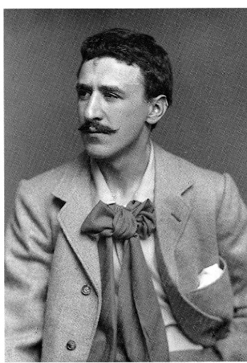
When was he born? ______________________________________________________________________________________________
Who was he married to? ______________________________________________________________________________________________
What did he do? ________________________________________________________________________________________________________________________________________________________________________________________________________________________________________________________________
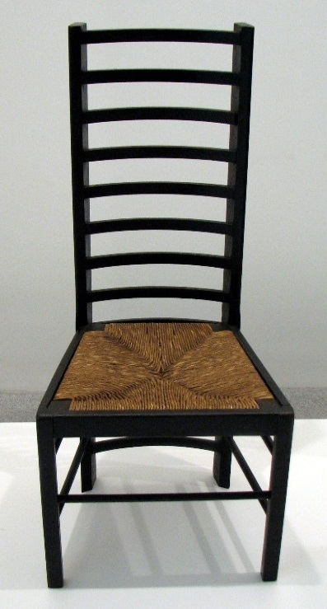
Images of mackintosh designs
Things to do:
- Create an image board in powerpoint of Mackintosh designs.
- Using these images to design, on paper, a clock that looks like a Mackintosh design.
- Use the 2D design program to turn your drawn ideas into a shape that can be laser cut.

Image from wikimedia.org
Charles Rennie Macintosh 2016 by Paul Wilby, English Martyrs School. Shared under a CC-BY 4.0 (Creative Commons Attribution 4.0 International License ) licence. Uses material from Wikimedia.com (Charles_Rennie_Mackintosh.jpg) and flikr.com

